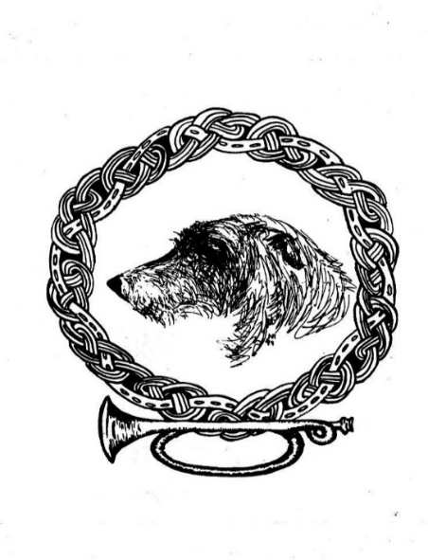
Northern California Irish Wolfhound Club 2026 Dues Notice
Note: Due June 1. Membership will lapse if not paid by July 15.

To Pay by Check, complete the following:
Name(s) ________________________________________________________
Address _________________________________________________________
Phone # Home__________________ Cell ____________________________
E-Mail __________________________________________________________
Check one: Associate Single ($35) Associate Family ($35)
Active Single ($35) Active Family ($45)
Mail with check payable to NCIWC to: Wendy Jepson, PO Box 234, Minden, NV 89423

To pay dues by credit/debit card:
Go to website www.nciwc.org and log in to your membership account. In the member profile section, there is a “pay” button. Follow prompts from there. You will be charged a convenience fee for using this service.
Thank you for supporting your Club!

