Northern California Irish Wolfhound Club

Members only

Non Sanctioned

Fun Match

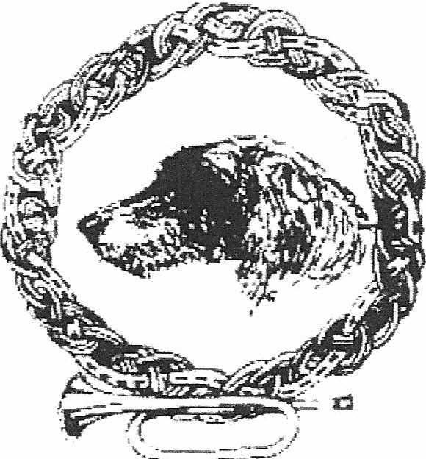

in association with these other

Northern California Sighthound Clubs :

Bay Area Rhodesian Ridgeback Club Portuguese Podengo Pequeno
Pharaoh Hound Fanciers of Northern California
Basenji Club of Northern California

9 am Saturday, June 22, 2013 at :

O'Hara Park School
1100 O'Hara Avenue Oakley, CA 94561

Close of Entries 6 pm on Wednesday, June 19, 2013

Show Secretary : Chris Thompson
Po Box 166, Pope Valley, CA 94567
Show Secretary : Chris Thompson, Po Box 166, Pope Valley, CA 94567

NCIWC - Fun Match

~ IN COMPLIANCE WITH AN AKC RULE, ENTRIES ARE LIMITED TO NCIWC MEMBERS ONLY ~

Entries must be received at the Match Secretary's address before

6:00 pm, Wednesday, June 19

Entries and fees (checks to "NCIWC") to the Match Secretary :

Chris Thompson,
Po Box 166, Pope Valley, CA 94567

~ Note : there will be NO "Day of" entries ~

Program : Saturday, June 22, 2013

    - Set-up (NCIWC) begins at 6.30 am
    - IW check-in begins at 8 am
    - IW check-in ends at 8.45 am
    - Do not be late for check-in
    - IW Judging begins at 9 am
    - Other breed ring times to be announced
    - One hour lunch break, at noon approximately

    - (NOTE : no lunch provided)
    - Drinking water provided - for the humans !
    - At approximately 1pm, Judging continues until done
    - Lure Course - Basenji Club - time tba

PICK UP AFTER YOUR DOG !

Help us to keep this wonderful site available.

Judge | Nitsa Trayler

Only puppies and adults without AKC major points shall be entered.

Classes (in deference to their age, Veterans will show first) :

Veteran Classes (male first)

male - 6 to 8 years
male - 8 years and over

female - 6 to 8 years
female - 8 years and over

Ribbon awarded for 1, 2, 3 & 4 place in each category

"I'm Still Here" Ribbons and Pewter plate awarded to all Veterans

Pewter Mug awarded to the oldest veteran, male or female

Puppy (male first)

male - 3-4 mo, 4-6 mo, 6-9 mo, 9-12 mo

female - 3-4 mo, 4-6 mo, 6-9 mo, 9-12 mo

Best puppy competition

Ribbon awarded for 1, 2, 3 & 4 place in each category

Pewter Plate awarded for Best Puppy and Best Opposite Sex puppy

Adult (male first)

male - 12 to 18 months
male - Bred by Exhibitor
male - Open

female - 12 to 18 months
female - Bred by Exhibitor
female - Open

Best Adult competition

Ribbon awarded for 1, 2, 3 & 4 place in each category

Pewter Plate awarded for Best Adult and Best Opposite Sex Adult

