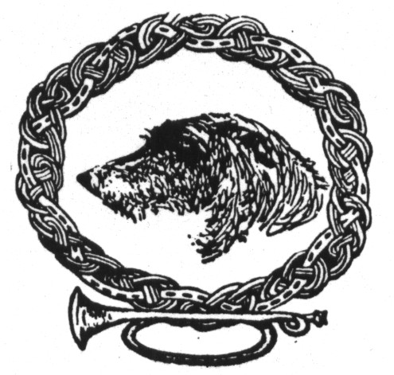Return To:
Robin Burchett Visit us at:
2213 Greenbrier Street WWW.NCIWC.ORG
Concord, CA. 94520-1441
(925) 689-9765

NORTHERN CALIFORNIA IRISH WOLFHOUND CLUB
MEMBERSHIP APPLICATION

There are three types of membership open to all persons sixteen years of age and older who are in good standing with the American Kennel Club and who subscribe to the purpose of the NCIWC Non-Profit Corporation.

Associate Membership(s):Non-voting member(s) of the Club who cannot hold office or be counted in a quorum.
Receives one copy of the Club's bi-monthly publication, The Hounds Bugle.
One Club Member-Sponsor required.
One year Associate Membership required before eligibility for Single or Family Active Membership.
Annual dues: $25.00
Single Active Membership: Voting member of the Club.
Receives one copy of the Club's bi-monthly publication, The Hounds Bugle.
Two non-related Active Member-Sponsors required.
One year as Associate Member required.
Annual Dues: $35.00
Family Active Membership: Same as Single Active Membership except:
Two voting Members of the Club sharing the same household.
Annual Dues: $45.00

Circle type of Membership applying for : ASSOCIATE - SINGLE ACTIVE - FAMILY ACTIVE

Name(s) :________________________________________________________________ Date:_____________
Address:_______________________________________________________ Phone number_______________
_______________________________________________________________Cell Phone__________________
Email:__________________________________________________________Fax:_______________________

Do you currently own an Irish Wolfhound?______Name(s)__________________________________________
__________________________________________________________________________________________
Please indicate the number of Irish Wolfhounds in your household that are: Show____ Spayed/Neutered _____
Breeding Stock_______ Breeder of your Wolfhounds_______________________________________________
Other dogs owned. Breed and names____________________________________________________________
__________________________________________________________________________________________
List other Dog Clubs belonged to, if any:_________________________________________________________
__________________________________________________________________________________________

Would you be willing to list your name with local animal shelters, etc. for Irish Wolfhound Rescue? Yes - No
Could you temporarily provide shelter and care for a homeless, purebred Irish Wolfhound until a permanent home was found? Yes - No

NORTHERN CALIFORNIA IRISH WOLFHOUND CLUB
Required Membership Questionnaire

In order to better serve our Members' interest in Irish Wolfhounds, please provide us with information that will be used as a guideline for future Club activities and as topics of interest for future Hounds Bugle articles.

What are your interests in Irish Wolfhounds?

Please code the following as:
(1) Definitely plan to participate actively
(2) Would like more information before deciding to participate
(3) Not interested at this time

_____ Conformation Showing _____Lure Coursing
_____ Obedience _____ Open Field Coursing
_____ Tracking _____ Health & Medical Updates
_____ Welfare & Rescue _____ Socialization Activities
_____ Agility _____ Therapy
_____ Other

Do you have any skills, expertise or training you would like to share with the Club? Any other comments?

By signing below, the applicant agrees to abide by the rules of the American Kennel Club and by the NCIWC By-Laws and Code of Ethics (refer to our Website www.nciwc.org for the current By-Laws and Code of Ethics). All applications are to be filed with the Membership Chairman and presented at the next meeting of the Club. Upon an affirmative vote of a majority of the Board the applicant will be accepted as a member.

_____________________________________ __________________________________
Signature of Applicant Signature of Applicant

_____________________________________ ___________________________________
Signature of Sponsor #1 Signature of Sponsor #2

Board approved: Yes___ No___ Date:____________ Dues amount received:___________________

For any application for membership that is effective after the first six months of the Corporation's fiscal year, the dues payable shall be reduced by 50% for that year only. Make check payable to NCIWC.

Associate Membership - $25.00 Single Active Membership - $35.00 Family Active Membership - $45.00

