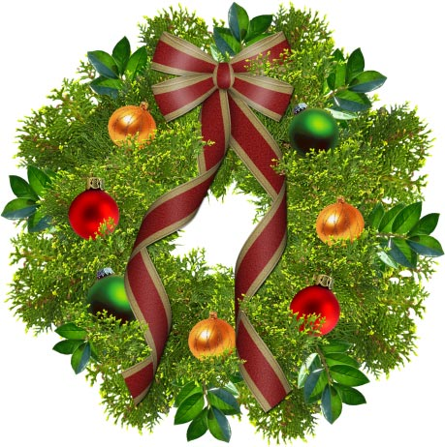

53nd Annual Napa Vintage Christmas Parade
Theme: Have a Holly Jolly Christmas
Saturday, November 28, 2015

Assembly time: 3:00 pm • Parade Begins: 5:00pm
RAIN OR SHINE
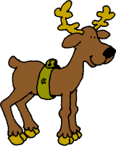

The Northern California Irish Wolfhound Club will participate again this year in Napa’s Christmas Parade. It will be held in Downtown Napa. We will assemble at 3:00 pm before the parade begins at 5:00 p.m. at First and Second Streets between Franklin and Main Streets.
Napans build floats, decorate cars, animals, bicycles, carts, and children, then march down the main streets of downtown Napa. Participants are encouraged to decorate using lights. The parade route is usually no more than a mile and Santa Claus will show up at the end of the parade. We are anticipating a few reindeer with Irish names and scruffy faces to add to the fun and joy of the event. It’s all free and all fun. Details about this year’s theme will be announced soon.

Please email Peggy Squires at pesquires@mac.com if you and your hounds would like to participate in this festive and fun holiday event. Please include the names and numbers of two legged participants as well as four legged participants.

We need two volunteers that are not walking leashed dogs, to carry the NCIWC banner and a van to follow the group for participant pick up during the parade if needed.

